### **Guest Login**

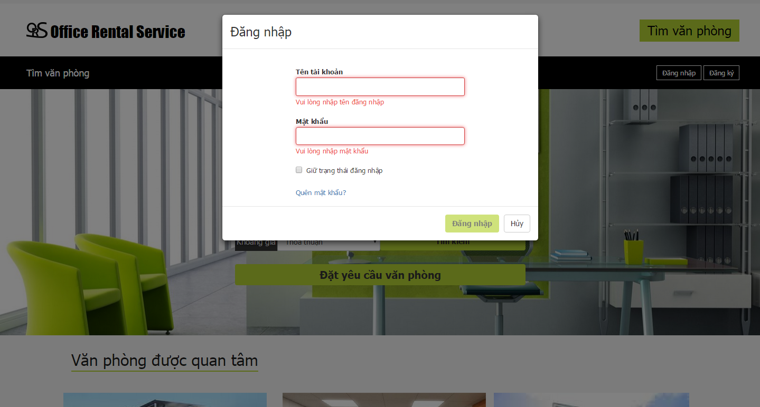

**Figure 1: Customer Login Page**

|  |  |
| --- | --- |
| **Step** | **Description** |
| 1 | Enter “Tên tài khoản” and “Mật khẩu”  (E.g: Tên tài khoản: usera. Mật khẩu: 12345678) |
| 2 | Click “Đăng nhập” |

**Table 1: Login Step**

### **Customer**

#### Search office

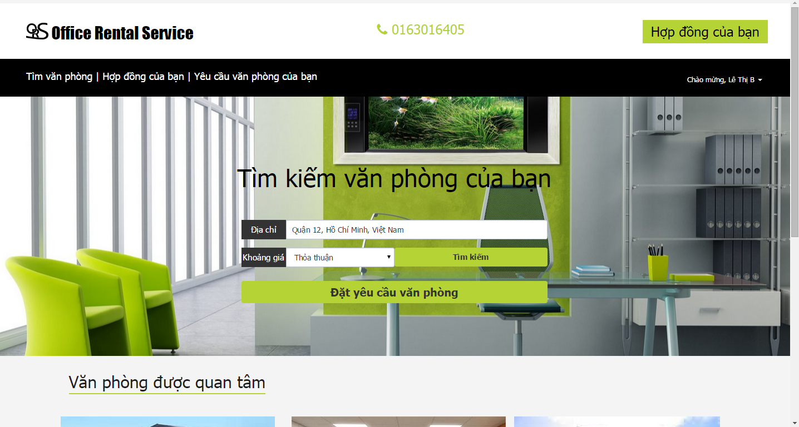

**Figure 2 : Search office**

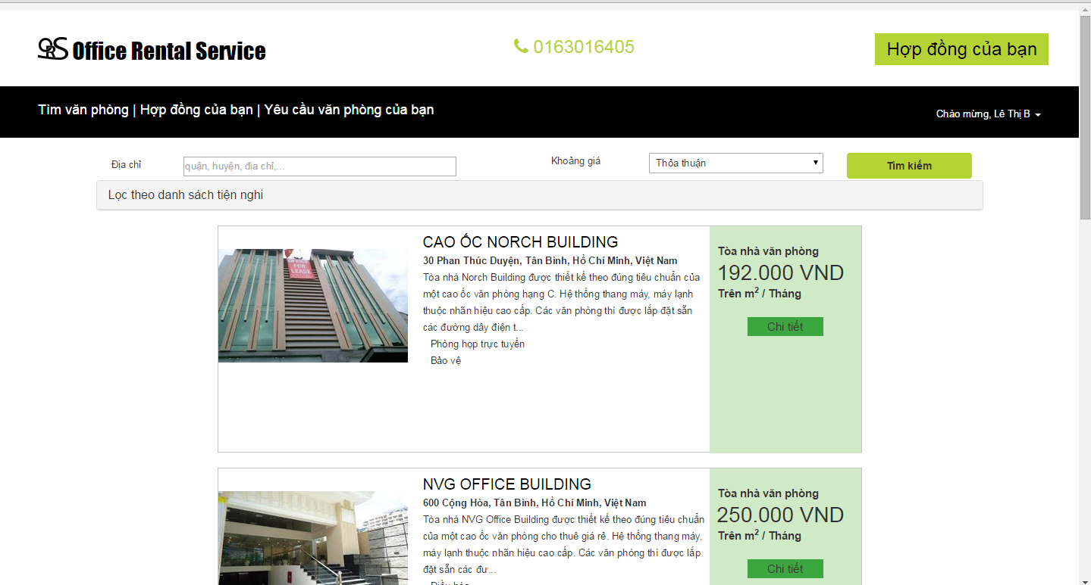

**Figure 3 : Search office**

|  |  |
| --- | --- |
| **Step** | **Description** |
| 1 | Fill “Địa chỉ” or “Khoảng giá” or both. |
| 2 | Click “Tìm kiếm” button. |
| 3 | Show result |

**Table 2: Search office**

#### View office detail



**Figure 4 : View office detail**

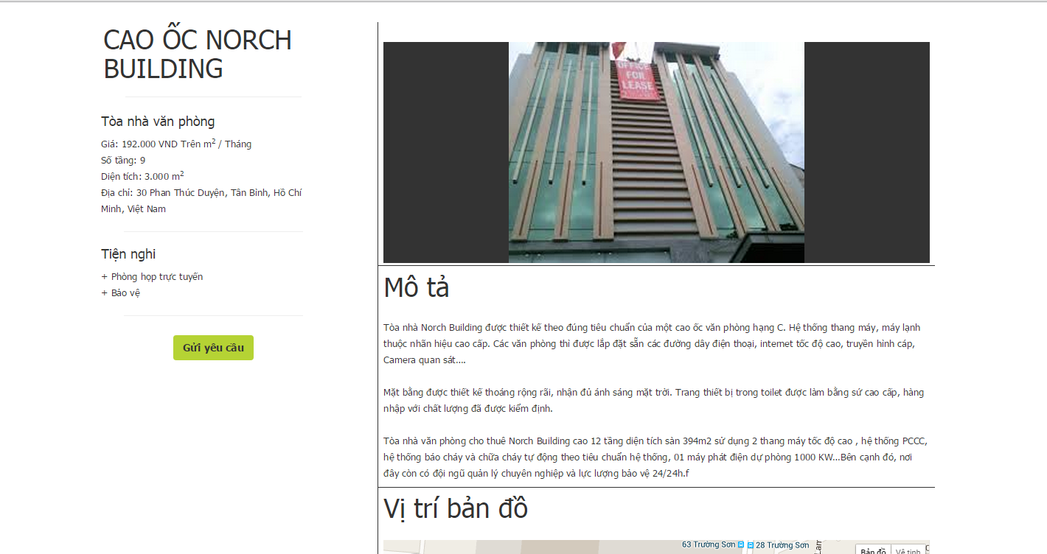

**Figure 5 : View office detail**

|  |  |
| --- | --- |
| **Step** | **Description** |
| 1 | Click “Chi tiết” on office. |
| 2 | Show detail |

**Table 3: View office detail**

#### Create appointment



**Figure 6 : Create appointment**

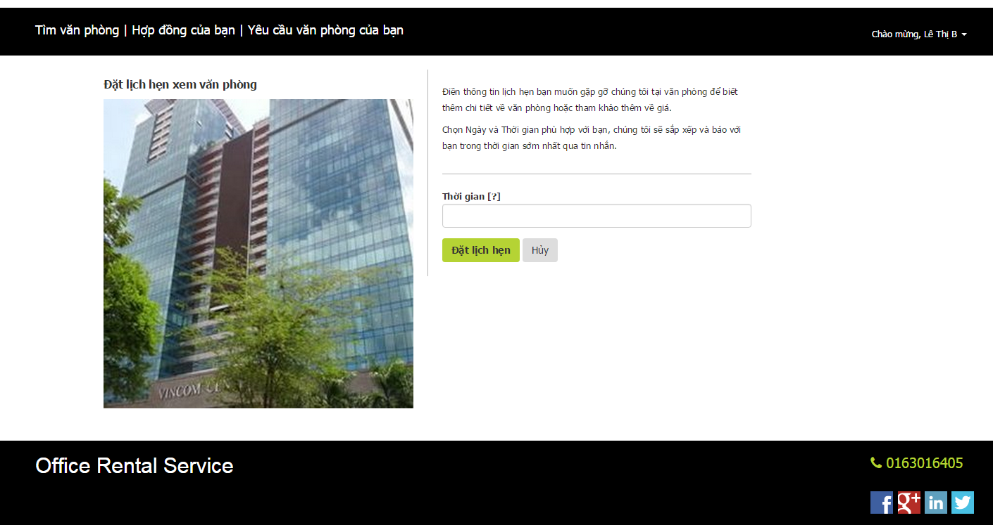

**Figure 7 : Create appointment**

|  |  |
| --- | --- |
| **Step** | **Description** |
| 1 | Click “Gửi yêu cầu” on office detail page. |
| 2 | Fill “thời gian” information |
| 3 | Click “Đặt lịch hẹn” |

**Table 4: Create appointment**